A Risk Management Interaction Chart

Below is a chart illustrating the interactions among strategy, risk appetite framework, ICAAP, stress testing, IFRS 9 and enterprise risk management. If I were to use connectors to indicate the linkages, there would be connectors with arrows at both ends all over the chart. For the sake of elegance, those arrow connectors are left out; however, everything is linked, aligned and changed with everything like an animated net.

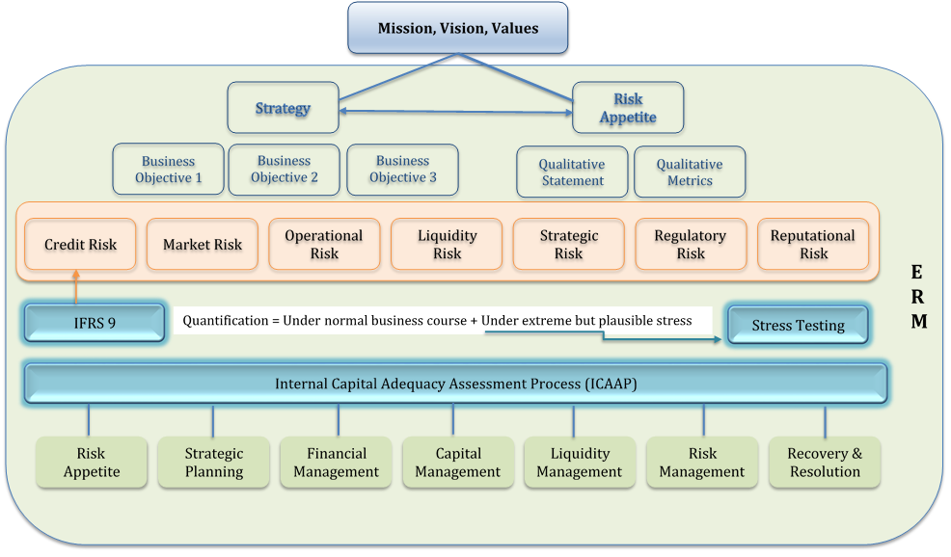

Mission, Vision and Core Values define what kind of organization it wants to be and how it conducts its business. Therefore, they dictate the organization’s strategies and business objectives and provide the initial expression of risk appetite.

Risk Appetite is defined as the types and amount of risk, on a broad level, an organization is willing to accept in pursuit of value. An organization’s risk appetite is determined by its risk capacity and risk constraints, and should be expressed in both qualitative statements and quantitative metrics. An optimal risk appetite framework can be established using a combination of top-down and bottom-up approaches.

Strategy and Business Objectives should be aligned with risk appetite. COSO’s newly published Enterprise Risk Management – Aligning Risk with Strategy and Performance (September 2017) indicates an industry trend to consider risks explicitly not only in strategy implementation but also in strategy selection. In my opinion, CEO and CRO are a single role splitting into two positions due to one person’s limitations in time, energy and attention span.

Risks are assumed once business activities are carried out. The most common types of risks include: credit risk, market risk, operational risk, liquidity & funding risk, strategic risk, regulatory risk and reputational risk. Under each major risk there could be sub-risks. Each material risk an organization is exposed to as well as risk interrelations should be identified, assessed, measured, monitored and reported.

ICAAP (Internal Capital Adequacy Assessment Process) provides a platform to assess and quantify material risks in terms of their impact on capital, earning, liquidity and other key strength indicators. Such assessment is conducted under business-as-usual conditions as well as under extreme but plausible stressed conditions, where stress testing comes into play. ICAAP integrates with all other key processes such as risk appetite, strategic planning, financial and capital planning and management, and liquidity planning and management.

Stress Testing is an integral part of ICAAP and serves as an important tool for both business and risk management. It includes scenario testing and sensitivity analysis. Stress testing is considered more art than science due to the fact that management judgment needs to be applied to the design and implementation of the stress tests.

IFRS 9 Program classifies and measures financial instruments held by an organization and generates forward-looking ECL (expected credit loss), which is fed into credit risk assessment as part of ICAAP. IFRS 9 is considered as a game changer because it is the first time in history that credit risk management methodologies/models drive accounting numbers and financial disclosure.

ERM (Enterprise Risk Management) has an omnipresence in every key process or program. This is because a journey to business success is a journey of managing risks. As a particular risk may represent opportunity or threat, every key decision is made to either explore opportunity or reduce threat. In the rare cases, the decision could be do-nothing, but that is just a tactic to see how the risk unfolds itself so that an appropriate response could be made. Along this line of reasoning, although the enterprise risk management framework is generally facilitated by an ERM function, it must be implemented across the whole organization by all three lines of defense.

